Question 1- David drew a column graph to show the average cost of petrol in six capital cities
Misleading Graphs Worksheet
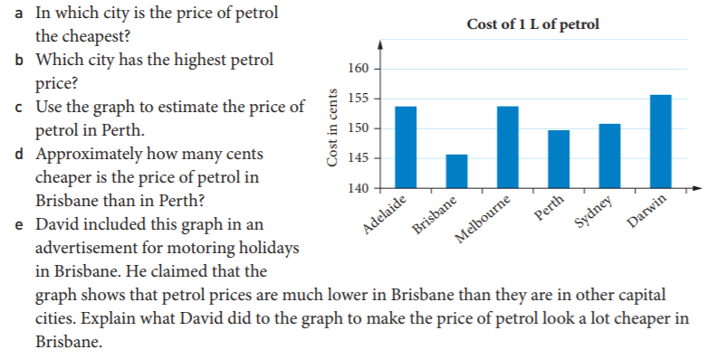
Question 2: Scott thinks that oil companies are ripping people off. He decided to investigate the price of petrol and the cost of crude oil. Scott displayed his information on a graph.
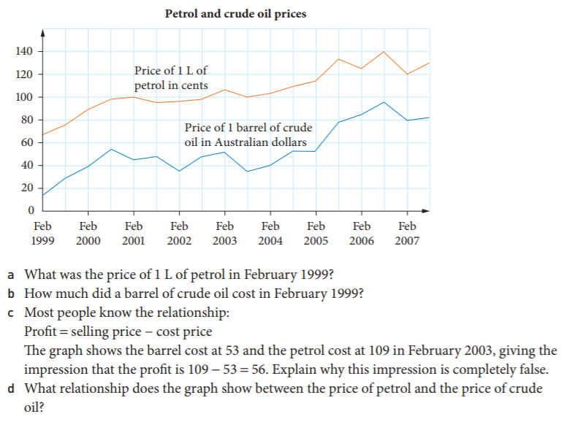
Question 3- This graph compares the average weekly wages in Malvolia ($700) and Australia ( $1400)

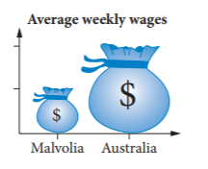 | 